

**Asia Pacific College**

**School of Computing and Information Technology**

**Magallanes, Makati City**

**PUBLIC SCHOOL RANKING SYSTEM**

**In Partial Fulfillment of the Requirements for the subject Quality**

**AYUNGON, Rhea-Eve M.**

**BURTON, Kathrine Danielle C.**

**JULIAN, Kyla Joyce M.**

**LLANTOS, Joneil Thom O.**

**APRIL 20, 2018**

**Table of Contents**

**I.** **INTRODUCTION** 3

**A.** **Project Overview** 3

**B.** **Project Team Members** 5

**C.** **Roles & Responsibilities** 5

**II.** **CONCEPTUAL FRAMEWORK** 7

**III.** **SOFTWARE PROGRAM OUTLINE** 7

**A.** **Organizational Chart** 7

**i.** **External Structure** 7

**ii.** **Internal Structure** 7

**B.** **List of Modules** 8

1. **INTRODUCTION**
2. **Project Overview**

Elementary education is the first part of the educational system, and it includes the first six years of compulsory education from grade 1 to 6, with an optional 7th grade offered by some schools. Major subjects include Mathematics, Science, English, Filipino and Araling Panlipunan. On the other hand, optional subjects include Music, Arts, Physical Education, and Health.

As of School Year 2017-2018, there are 22.9 Million students that are enrolled in public schools in the Philippines and the country’s Department of Education has been doing their job in providing quality education both for private and public sectors. However, there are still room for improvement to advance the education system in the country.

The team believes that a student’s performance can be enhanced and strengthen with the help of analytics. Through a systematic analysis of data and statistics, the team, together with the client, Department of Education, may focus on students’ performance by viewing how the students perform in their major subjects. This tool will not be used for comparison of students, but will focus more on the strengths and weaknesses of a pupil. By acknowledging and knowing these factors, the teachers, together with their respective schools can keep track of their students’ performance and help them grow in their academics. Also, through this tool, the school may know how well they perform in educating their students.

How do we maximize the use of analytics? The team opted to use moodle which is an online platform to administer Quarterly Assessment Exams. Each student will have an account and will automatically be enrolled in a course for their respective grade level. Once the students have answered all Quarterly Assessment Exams, the results will then be stored in the admin’s database containing the Student Name, Student ID, Exam Answers, and Answer Key. This database will be connected to the system and analytics would be connected to the team’s system in order to have the table automatically updated.

The team, however, is very much conscious on the budget that will be allocated for the system. The team believes that implementing moodle in every public school would require a fortune from DepEd. Therefore, another medium that can connect to analytics is the concept of Optical Mark Recognition (OMR) but proposing to replace the costly OMR machine using a regular ADF scanner. To facilitate this, Quarterly Exams are distributed in hard copies and would be scanned for checking. The results would also be extracted from the OMR to the system and would then be displayed on the dashboard for viewing.

1. **Project Team Members**

The following are the list of team members with their respective roles and their emails.

|  |  |  |
| --- | --- | --- |
| **NAME** | **ROLE** | **EMAIL** |
| Kyla Joyce M. Julian | Project Manager | [kmjulian@student.apc.edu.ph](mailto:kmjulian@student.apc.edu.ph) |
| Joneil Thom O. Llantos | Lead Developer, Database Coordinator, Quality Assurance and Control Coordinator |  |
| Rhea-Eve M. Ayungon | Developer, Quality Assurance and Control Analyst, Integration Manager | [rmayungon2@student.apc.edu.ph](mailto:rmayungon2@student.apc.edu.ph) |
| Kathrine Danielle C. Burton | Database Analyst,  System Analyst, Documentation Lead | kdcburton@student.apc.edu.ph |

1. **Roles & Responsibilities**

The following are the roles and responsibilities of the staff needed to implement the project. Responsibilities from the respective roles are gathered from PayScale.com, website providing salary, benefits, and compensation information.

|  |  |  |
| --- | --- | --- |
| **NAME** | **ROLES** | **RESPONSIBILITIES** |
| Kyla Joyce M. Julian | Project Team | * Responsible for managing and leading the team * Monitor project progress and performance * Manage coordination with the team and client to ensure if the organization’s requirements are being fulfilled * Detailed project planning |
| Joneil Thom O. Llantos | Lead Developer, Database Coordinator, Quality Assurance and Control Coordinator | * Programs software and writing of operating manuals * Works with system developer to ensure the system compatibility and meet organization’s requirements * Modifying and testing comprehensively the system to ensure the reliability of it * Undertake on system processes and analysis * Apply feasible solutions to possible problems |
| Rhea-Eve M. Ayungon |  | * Analyze client requirements * Works with lead developer to ensure system compatibility and meet organization’s requirements * Responsible in ensuring the quality of the end product and its process * Responsible in system integration |
| Kathrine Danielle C. Burton | Database Analyst,  System Analyst, Documentation Lead | * Researching and examining current system and consulting users * Responsible in training the users and perform adequate support * Ensuring the security of databases and perform maintenance to guarantee the system’s performance * Responsible in documenting different phases of the project |

1. **CONCEPTUAL FRAMEWORK**
2. **SOFTWARE PROGRAM OUTLINE**
3. **Organizational Chart**
4. **External Structure**

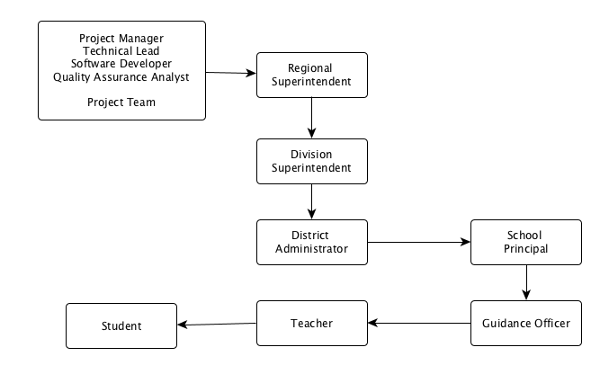

1. **Internal Structure**

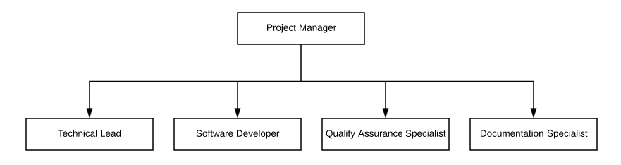

1. **List of Modules**